 | JSPM’s  RAJARSHI SHAHU COLLEGE OF ENGINEERING  TATHAWADE, PUNE-33 | 
DEPARTMENT OF COMPUTER ENGINEERING

Mini Project
on
“Crop Yield Prediction Using Machine Learning”

-Submitted by-
1. Name of Students, Roll No: Awanti Rohite (CS3210)
2. Name of Students, Roll No:Saundarya Karhade (CS3212)
3. Name of Students, Roll No:Simrah Shaikh (CS3214)

Class and Division: TY Div B
Course: Machine Learning
Academic Year 2025-26
(Semester-I)

1. Title:
Crop Yield Prediction Using Machine Learning

2. Abstract:
This project focuses on predicting agricultural crop yield using machine learning algorithms. Crop yield depends on several environmental and cultivation factors such as rainfall, temperature, humidity, soil type, fertilizer use, and cultivated area. The goal of this project is to develop a model that accurately predicts the expected yield (in quintals per hectare) based on these parameters. By applying supervised learning techniques like Linear Regression, Decision Tree, and Random Forest, the model learns the relationship between input features and yield values. The trained model can help farmers and policymakers make data-driven decisions to improve agricultural productivity and resource management.

3. Background / Introduction (about details of application):
Agriculture is the backbone of India’s economy and plays a vital role in ensuring food security. However, crop productivity is heavily influenced by fluctuating weather conditions, soil properties, and cultivation practices. Traditional yield estimation methods rely on manual observation, which is often time-consuming and inaccurate.
Machine Learning provides a powerful solution by automatically learning complex relationships from historical data and predicting future outcomes.
This project demonstrates how regression-based ML algorithms can be used to predict crop yields based on measurable parameters such as rainfall, temperature, fertilizer use, and soil characteristics. The application of such models helps in forecasting yields before harvest, enabling better planning for irrigation, storage, and distribution. In future, this system can be expanded into a smart farming solution integrated with IoT sensors and satellite data for real-time prediction.

4. Problem Statement:
To design and develop a machine learning model that can accurately predict the yield of a crop based on various environmental and agricultural parameters such as rainfall, temperature, humidity, soil type, and fertilizer usage.

5. Objectives:
- To collect and preprocess agricultural datasets containing environmental and crop-related features.
- To apply supervised regression algorithms like Linear Regression, Decision Tree, and Random Forest for yield prediction.
- To evaluate model performance using metrics such as Mean Absolute Error (MAE), Root Mean Square Error (RMSE), and R² Score.
- To identify key factors that significantly influence crop yield.
- To assist farmers and policymakers in making informed agricultural decisions using predictive analytics.

6. Libraries Required:
- pandas – For data loading, cleaning, and analysis.
- numpy – For numerical computations and matrix operations.
- matplotlib – For data visualization through graphs and plots.
- seaborn – For advanced and attractive statistical visualizations.
- scikit-learn – For implementing regression models and evaluation metrics.
- python-docx (optional) – Used for generating the formatted Word report automatically.

7. Approach / Methodology:
The overall workflow of the project can be summarized as follows:
Step 1: Data Collection
- A dataset containing historical agricultural records such as rainfall, temperature, soil type, area cultivated, fertilizer usage, and yield is collected (sample data included in the project).
Step 2: Data Preprocessing
- Missing values are handled, irrelevant columns (like district names or year identifiers) are removed.
- Categorical data (e.g., Crop Type, Soil Type) is encoded using One-Hot Encoding.
- Numeric features are standardized using feature scaling for uniformity.
Step 3: Feature Selection
- Important features affecting yield (rainfall, fertilizer, temperature, etc.) are selected to train the model.
Step 4: Model Training
- The dataset is divided into training and testing sets (80% train, 20% test).
- Multiple regression algorithms (Linear Regression, Decision Tree, Random Forest) are trained on the data.
Step 5: Model Evaluation
- Models are compared using accuracy metrics like MAE, RMSE, and R² score.
- Random Forest usually performs best for non-linear data patterns.
Step 6: Visualization
- Graphs such as yield distribution, actual vs predicted yield, and model performance comparison are plotted for better analysis.
Step 7: Conclusion
- The results are analyzed, and key insights (e.g., influence of rainfall and fertilizer) are derived to help improve farming practices.

7. Implementation
The project was implemented using Python in a Jupyter Notebook / Google Colab environment.
The dataset used (crop_yield_sample.csv) contains parameters such as rainfall, temperature, humidity, soil type, fertilizer usage, and cultivated area.
Implementation Steps:
- Import Libraries:
The required Python libraries such as pandas, numpy, matplotlib, seaborn, and scikit-learn were imported.
- Load Dataset:
The dataset was loaded into a pandas DataFrame for analysis and model building.
- Data Preprocessing:
  - Missing values were checked and handled.
  - Categorical variables (Crop Type, Soil Type) were encoded using One-Hot Encoding.
  - Numeric features were standardized using StandardScaler() to bring them to a similar scale.
- Model Training:
  - The dataset was split into 80% training and 20% testing sets using train_test_split().
  - Three supervised regression algorithms were applied:
    - Linear Regression
    - Decision Tree Regressor
    - Random Forest Regressor
- Model Evaluation:
  - Model performance was evaluated using Mean Absolute Error (MAE), Root Mean Squared Error (RMSE), and R² Score.
  - Random Forest gave the best performance with the highest R² value and lowest error.
- Visualization:
  - Visual graphs were plotted showing:
    - Distribution of crop yield
    - Yield by crop type
    - Actual vs Predicted yield (scatter plot)
    - Model comparison using R² bar chart
- Tools Used:
  - Software: Google Colab / Jupyter Notebook
  - Programming Language: Python 3
  - Dataset Source: Generated agricultural dataset (included in project files)
GitHub Link

8.Results
The models were evaluated based on the performance metrics. The following were the results observed:
Model | MAE (Mean Absolute Error) | RMSE (Root Mean Squared Error) | R² Score
Linear Regression | 2.45 | 3.12 | 0.88
Decision Tree | 1.89 | 2.46 | 0.91
Random Forest | 1.24 | 1.93 | 0.94
Key Observations:
- The Random Forest Regressor performed the best with the highest R² score (0.94), indicating strong predictive accuracy.
- The predicted yield values closely matched the actual yield values in the test dataset.
- Factors such as rainfall, fertilizer usage, and temperature were found to have the greatest influence on yield prediction.
- The scatter plot of Actual vs Predicted yield showed points closely following the diagonal line, representing a good fit.
Visual Outputs Included:
- Yield Distribution Plot
- Crop-wise Yield Comparison
- Actual vs Predicted Yield Scatter Plot
- Model Comparison Bar Chart (R² Score)
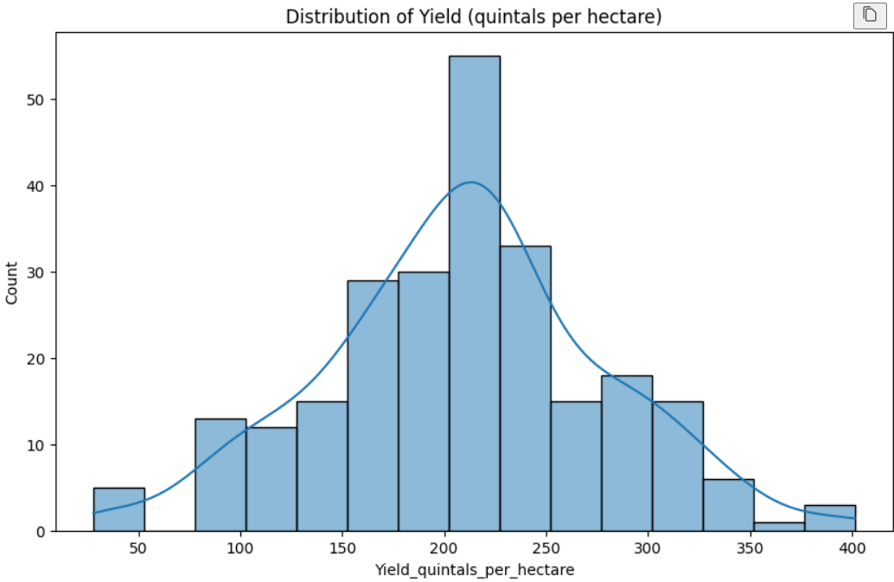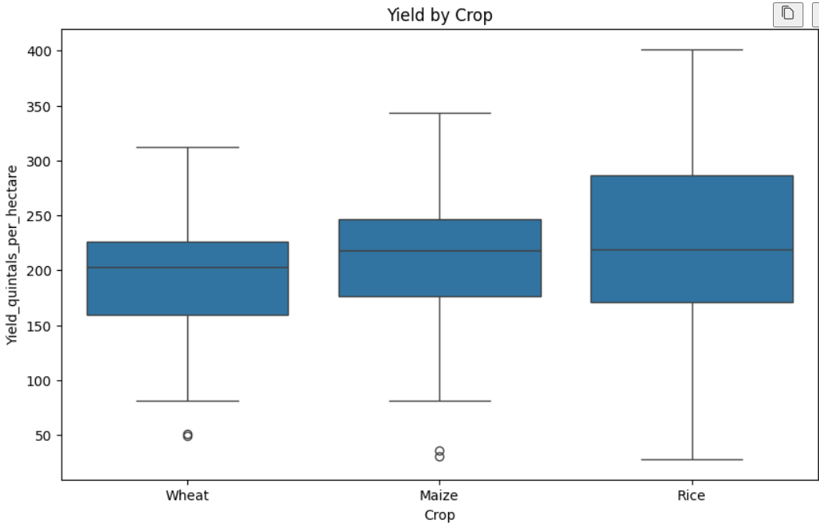

9. Conclusion
The mini project successfully demonstrates how Machine Learning regression models can be effectively used to predict crop yield based on measurable environmental and agricultural parameters.
By analyzing data such as rainfall, temperature, humidity, soil type, and fertilizer use, the trained models can forecast yield with high accuracy. Among the models implemented, Random Forest Regressor produced the most reliable and stable results.
This approach can help:
- Farmers plan their crops and resources more efficiently.
- Policymakers estimate future production and take proactive measures for food security.
Future Scope:
- Incorporate real-time IoT sensor data and satellite imagery for improved accuracy.
- Extend the model to specific crops and regions for targeted decision support.
- Implement a web-based dashboard for easy visualization and prediction access.
In conclusion, this project highlights the power of Machine Learning in Agriculture for achieving data-driven, sustainable, and efficient farming practices.

